# LAB # 09

# Fall 2024

**Control Systems Lab**

Submitted by: MUHAMMAD SADEEQ

Registration No.:**21PWCSE2028**

Class Section: **C**

“On my honor, as student of University of Engineering and Technology, I have neither given nor received unauthorized assistance on this academic work.”

Student Signature: ______________

Submitted to:

**Engr. Dr. Muniba Ashfaq**

Department of Computer Systems Engineering

University of Engineering and Technology, Peshawar

**Steady State Error Analysis using Simulink**

**Objective:**

* To use the concepts of Simulink to analyze the steady state errors

**Problem Statements:**

**Task1**

Plot on one graph Plot on graph the error signal for the input of 5u(t) with different values of k=50,500,1000,5000.

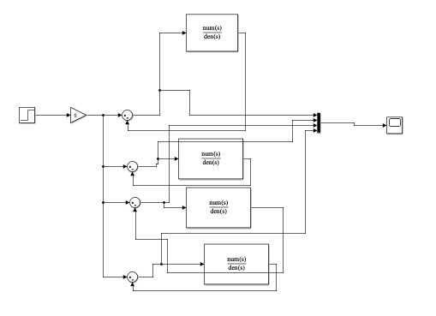

**Output**

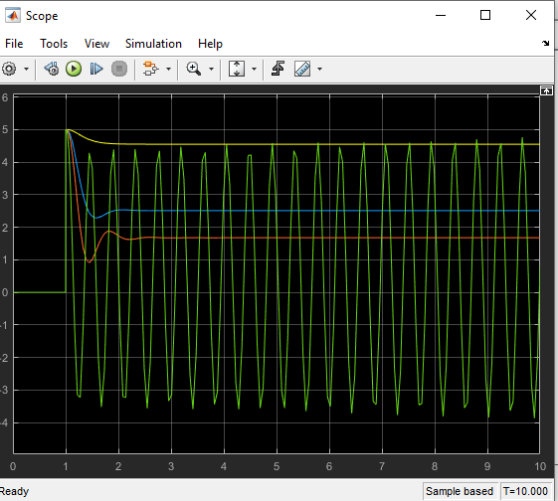

**Task 2**

Plot on one graph Plot on graph the error signal for the input of 5tu(t) with different values of k=50,500,1000,5000.

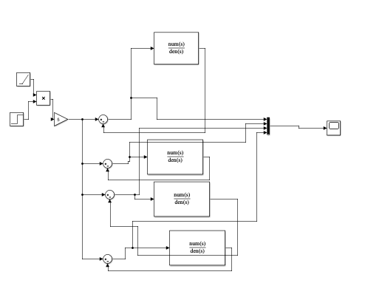

**Output**

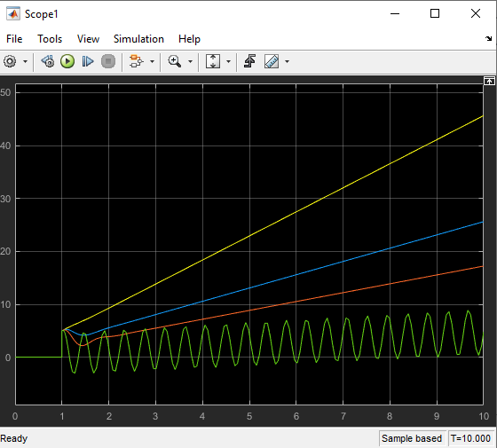

**Task 3**

Plot on one graph Plot on graph the error signal for the input of 5t 2u(t) with different values of k=50,500,1000,5000.

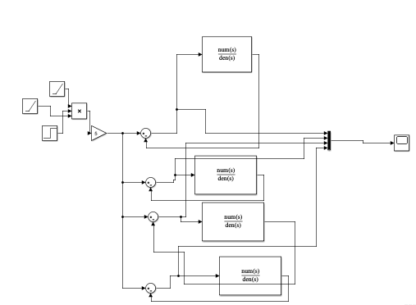

**Output**

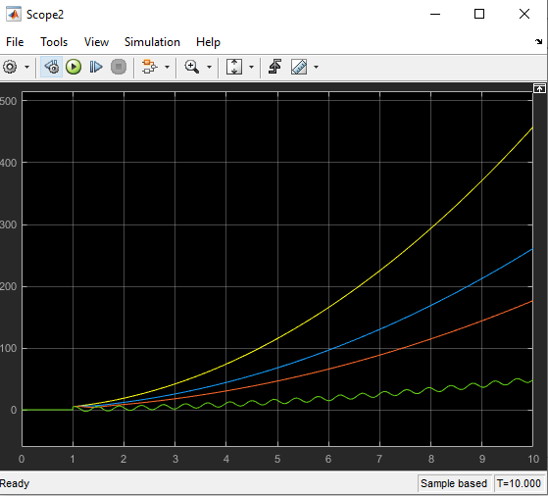

**Lab Report Conclusion**

In this lab, SIMULINK was used to design the system with different components of adders and step signal blocks. Different transfer function systems were added with varying values which were passed to the scope block to observe it visually.